(A BETTER ACCESS TO HEALTH)

P. O. Box GP 2821 Email: beautifulcreationsgh@yahoo.com
Accra - Ghana bcclgh@gmail.com
Tel: (233) 0302 667171, Hotline: 0243111199 Website: www.bcmedicals.com
Fax: (233) 0302 666585 www.beautifulcreationsgh.com Your Ref:
Our Ref: Date: 9th February, 2026

Sealed Quotation No: My Ref: GHS/RHB/26/AW/PQ/NM/1Q

BOLGATANGA REGIONAL HOSPITAL
P. O. BOX 26,
BOLGATANGA,
UPPER EAST REGION

SUPPLY, DELIVERY OF NON-MEDICINES CONSUMABLES

- Bid Form

- Price Schedule

- Company Certificates

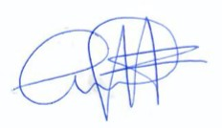
Yours faithfully,

…………………
Kwaku Ansong
Managing Director

